**ER MODEL (** [**Link**](https://lucid.app/lucidchart/c54eb8b0-1839-47b3-9d40-86efa339ab39/edit?invitationId=inv_05fe5998-18ce-409f-aae9-d30f389c3b19&page=0_0#) **)**

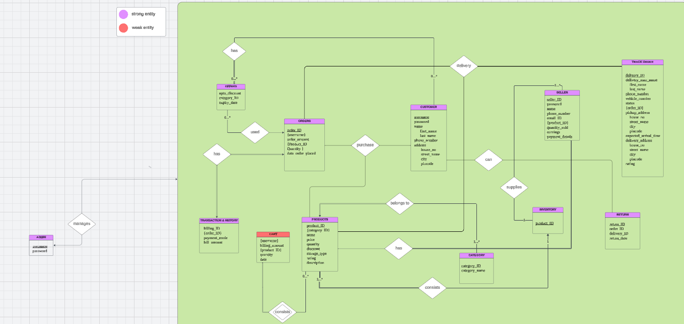

**RELATIONAL MODEL (** [**Link**](https://lucid.app/lucidchart/3576a887-9e59-406c-bbe2-eb484948c95f/edit?invitationId=inv_5028ffd3-e1bb-4ece-904e-2a7f66e800cc&page=0_0#) **)**

